Game Design Document

Fill up the following document

1. Write the title of your project.

TITANS, long live the king

1. What is the goal of the game?

Goal of the game is to team up with the titans and eliminate any treats that arise against the eart like rouge titans and terrorists

1. Write a brief story of your game.

This game is based on the legendary pictures titan monsterverse,

where we live in aworld with prehistoric beigs known as titans our

goal is to unite with the titans to create a peaceful world but for that we need power wich titan do have,so I’d like it to be like the pokemon

game that has a prety decent story line and players

1. Which are the playing characters of this game?

* Playing characters are the ones who respond to the user based on the input from the user.
* Cars, monkeys, dinos, wizards, etc., are the playing characters in the game.

|  |  |  |
| --- | --- | --- |
| Number | Character Name | What can this character do? |
| 1 | The main character as a person,  Name as user’s preference | Mc,controler |
| 2 | Titans | Powers,leveling up,attacks |
| 3 | Cars,planes,ships | transportation |
| 4 |  |  |
| 5 |  |  |
| 6 |  |  |
| 7 |  |  |
| 8 |  |  |

1. Which are the Non-Playing Characters of this game?

* Non-Playing characters are the ones that don't have an action or behavior when the user interacts with the game.
* Hurdles, stones, bananas, coins, etc., are non-playing characters in the game.

|  |  |  |
| --- | --- | --- |
| Number | Character Name | What can this character do? |
| 1 | Family | Suggestions, advices,support,etc |
| 2 | friends | support |
| 3 | hurdles | obstacle |
| 4 | Villain | Story line |
| 5 | Grunts | Obstacle |
| 6 | People | Obstacle,support,  Advice,give you issues to solve,sell |
| 7 |  |  |
| 8 |  |  |

Draw your imagination of this game. What does this game look like?

* Draw the game either on your computer or on paper.
* Add images of the game scenes to show each of the playing and non-playing characters at least once.

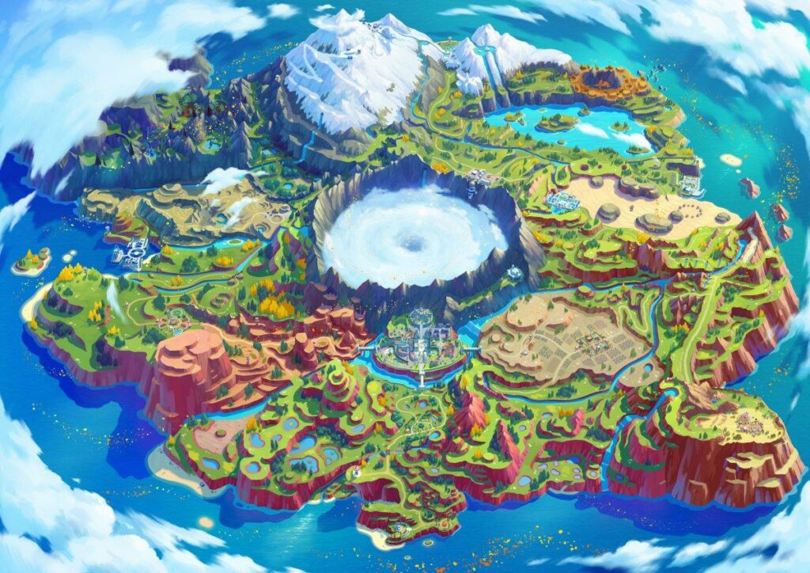

Game map,

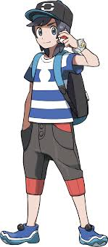

MC,

How do you plan to make your game engaging?

I am tinking of rule and battle stadiums and online pvps and a bigger world wide map,